

**Subject: Programming Fundamentals (Lab)**

**Mega Quiz**

**Total Marks = 20**

**Instructions for the Submission:**

* **Attempt all the questions and provide complete code with proper output screenshots as we discussed in the class.**
* **Attempt all questions provided in Word File / PDF. Don’t attached other documents.**
* **Due Date: Tuesday 18th January.**
* **Upload your proper Word document / PDF on Google Classroom before the due date and time.**
* **Must write your full name and SAP ID in required field below. No paper will be accepted without proper student details.**

**LATE SUBMISSIONS WILL NOT BE ALLOWED.**

**VIVA WILL ALSO CONDUCTED AFTER SUBMISSION.**

**Student Name:**

**Student SAP ID:**

**Q1: Write down the code for the following programs:** [8]

1. Write a program in C++ which is used to ask the user to enter the array size [1] then it will ask to enter the array elements [1], then it will finally ask to enter a number to be search in the given array [1] and check whether it is present in the array or not [1], if it is present then at which position [1].
2. Write a program in C++ to declare a 2D array of character type [1] with size 4X3 your array should hold only character values [1] if user enter any other value it should print invalid entry? [1]

**Q2: Write down the code for the following program:** [10]

1. Write a C++ program that prints on the screen following diamond shape with given series of numbers. (Hint: Using Nested For Loop) [5]

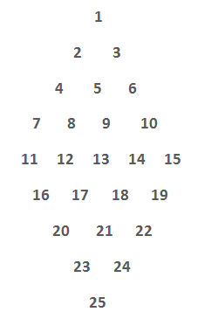

**Sample Output:**

1. Write a program which prints the number from 0 to 9 [1] and gives a running total [1]. Use 2 integer type variables, count and total.

Write this program using **“for loop”** and **“while loop”.** Combine both programs using **DO-While Loop** [1].

Program should display the following option.

Press “F” for “For Loop output”

Press “W” for the “While Loop output” [1]

Program should ask from the user in the end “DO you want to run this Program again??” [1]

**NOTE: Program menu choices must not be case sensitive.**

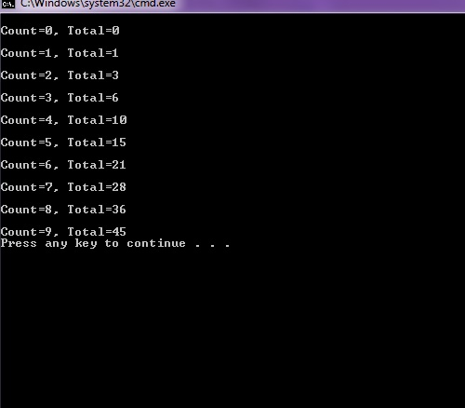

**Q4: Define the following with examples:** [2]

1. Write down any 5 pre-defined keyword used in C++ programming language except data types [0.5].
2. What the purpose of continue and break statement [0.5].
3. Define the difference between while and do-while loop [0.5].
4. Write down the name of at least five data types used in C++ with their purpose [0.5].

**Start writing down your answers from here………………**